Question 1:

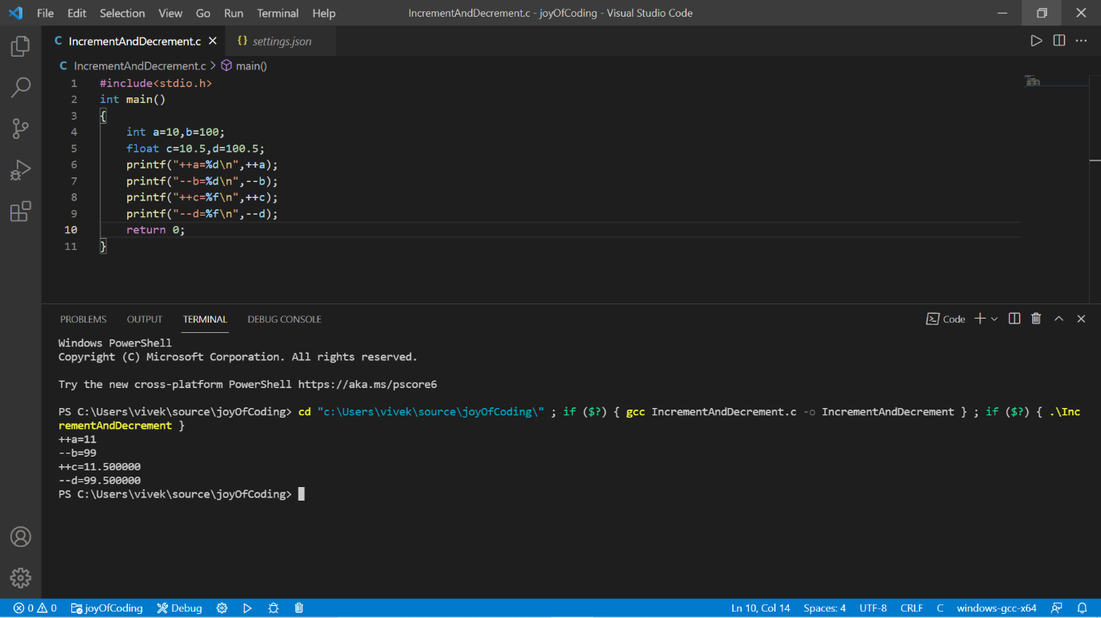

Question 2:

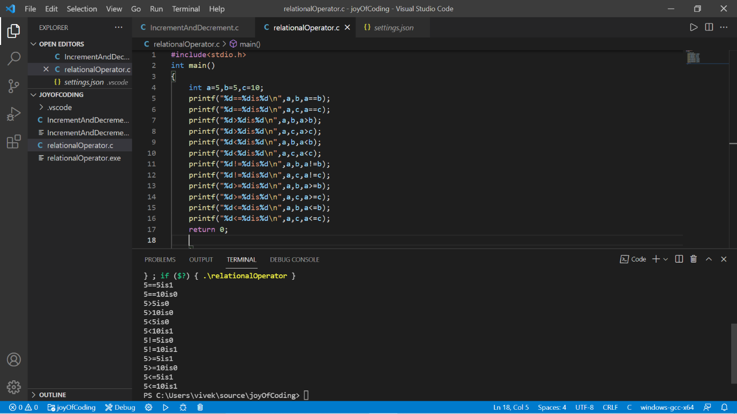

Question 3:

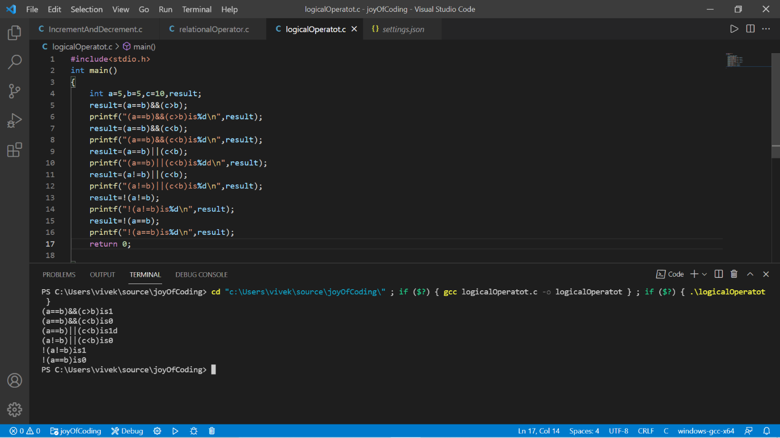

Question 4:

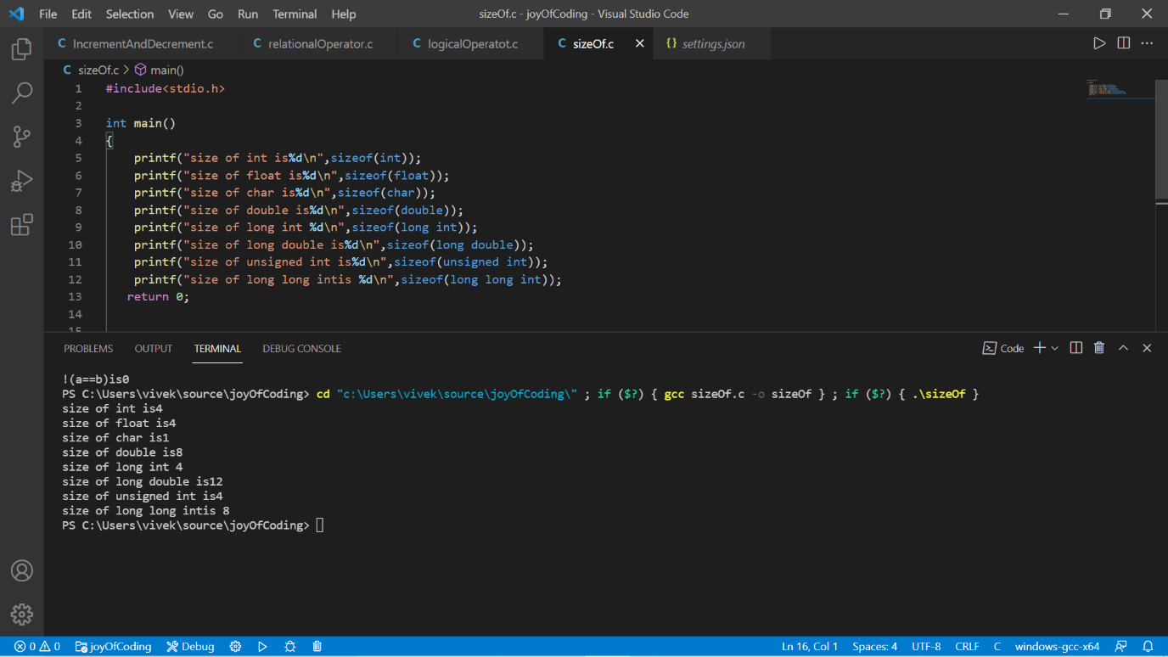

Question 5:

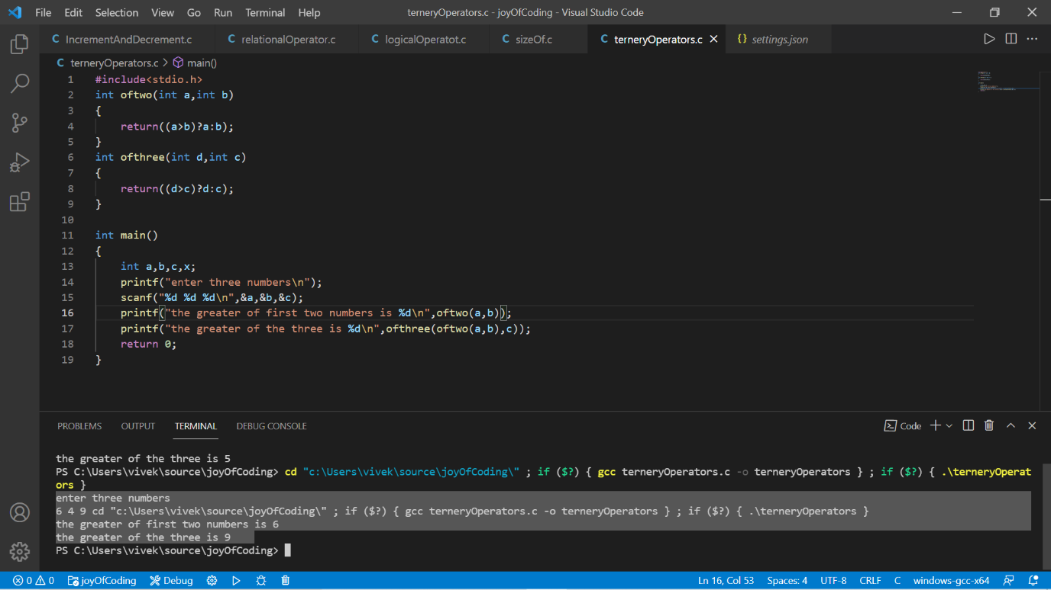

Question 6:

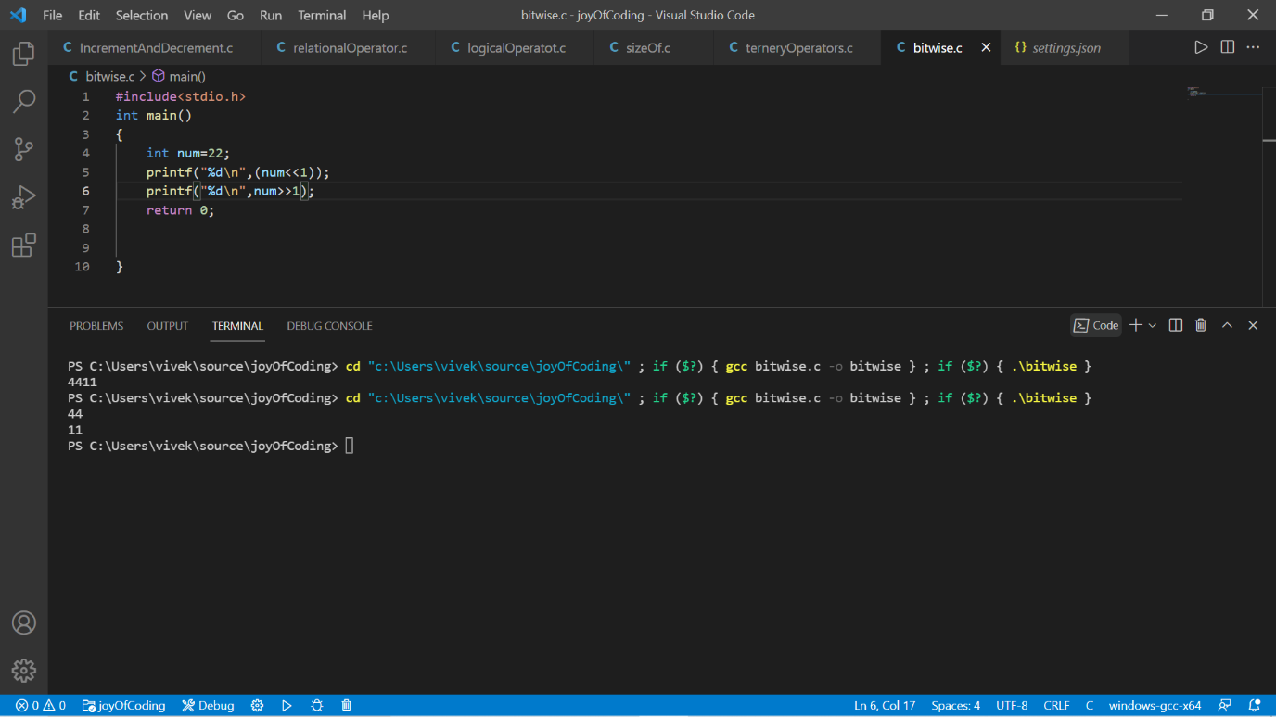

The number (num = 22) can be represented in binary as:

22 1 0 1 1 0

When we apply left shift operator (<< 1) it shifts the binary bit by one place to the left , thus making

num 1 0 1 1 0 0 (in binary) the decimal equivalent of this new number will be 44.

Similarly when we apply right shift operator num becomes 11.

In short the left shift(<<) operator multiplies the number by 2 and the right shift(>>) operator divides the number by 2.